PORTFOLIO

FLYNN’S WEBSITE

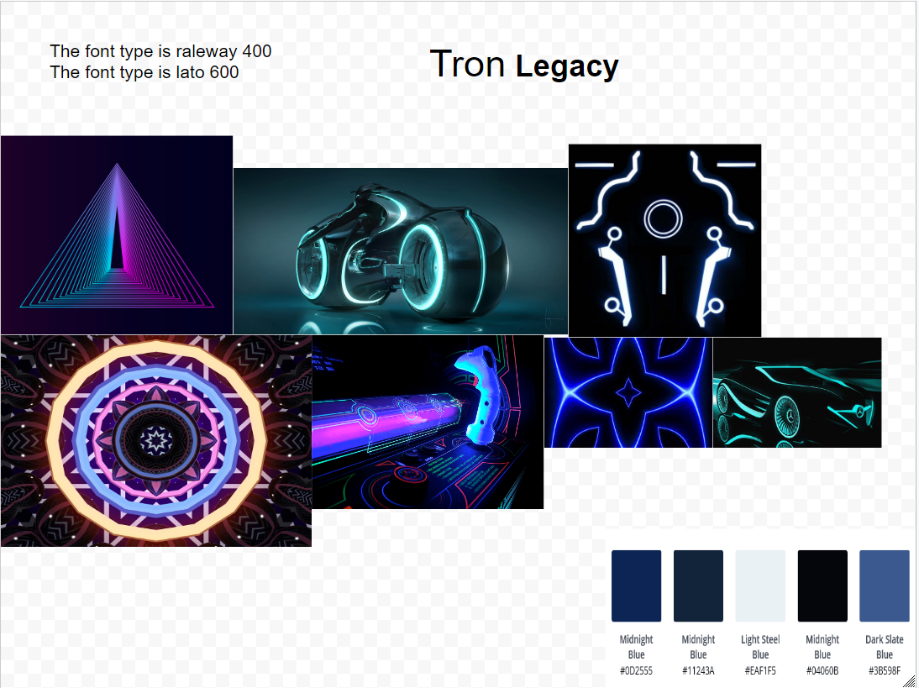

Semisi Funaki

FLYNN’S ARCADE

Contents Page

RESEARCH 3

DESIGN BRIEF 4

DESIGN SKETCH 5

Final concept/Design 6

BIBLOGRAPHY 7

EVALUATION 8

# RESEARCH

We’ve been researching how to design our own website using notepad++, and how to create our own repositories on GitHub. We’ve also used Logomakr to create our own logo for our websites and price tags. We have been looking at websites like JB-HI-FI and EB- Games, so it could help us create our Flynn website.



# DESIGN BRIEF

Flynn's Arcade has been slowly losing money as the trend for accessing video games has moved away from social 'video game arcades' to at home 'video game consoles' such as the Atari and Commadore 64. Flynn wants to reposition his business as a venue for selling new games and trading used games. Flynn wants you to design and create ‘alpha phase’ website that communicates his new business model.

Criteria:

-Use images (wisely)

- Keep your website pages consistent

-Include well-designed and written headlines

-Segment key information with bullet points

-Make sure your entire website is responsive

-Provide information for emails and contact pages

# DESIGN SKETCH

## Final concept/Design

## BIBLOGRAPHY

<http://tron.wikia.com/wiki/Flynn's_Arcade>

<https://github.com/>

<https://getbootstrap.com/>

<https://logomakr.com/>

<https://www.ebgames.com.au/>

<https://www.jbhifi.com.au/>

<http://www.mhs-devs.com.au/designToolKit/>

<https://www.google.com/maps/>

## EVALUATION